Task 5.1: EP and BVA Techniques

EP поділяє вхідну область на класи даних, з яких можуть бути отримані тестові випадки.

Розглянемо діапазони, визначені для кожної букви.

|  |  |  |
| --- | --- | --- |
|  | Valid Inputs | Invalid Inputs |
| A (>= 88) | 88 89 90 | 87 101 |
| B (>= 80) and < 88 | 80 85 87 | 79 88 |
| C (>= 71) and < 80 | 71 75 79 | 70 81 |
| D (>= 62) and < 71 | 62 65 70 | 61 72 |
| E (>= 50) and < 62 | 50 55 61 | 49 63 |
| F (< 50) and >= 26 | 26 40 49 | 25 50 |
| FX (< 26) | 25 15 0 | -1 26 |

BVA зосереджується на краях введення, оскільки вони, швидше за все, містять помилки.

Розглянемо межі для кожного класу.

(Lower Boundary + - 1, Upper Boundary + - 1)

|  |  |  |
| --- | --- | --- |
|  | Valid Inputs | Invalid Inputs |
| A (>= 88) | 88 89 100 | 87 101 |
| B (>= 80) and < 88 | 80 81 87 | 79 88 89 |
| C (>= 71) and < 80 | 71 72 79 | 70 80 81 |
| D (>= 62) and < 71 | 62 63 70 | 61 71 72 |
| E (>= 50) and < 62 | 50 51 61 | 49 62 63 |
| F (< 50) and >= 26 | 26 27 49 | 25 50 51 |
| FX (< 26) | 0 1 25 | -1 26 27 |

Task 5.2: Decision Table Technique

Conditions:

1. Registered on site (Yes/No)

2. Two-way ticket (Yes/No)

3. Number of Tickets (1, 2, >2)

Actions:

1. Apply 5% discount

2. Apply 10% discount

3. Apply additional 3% discount

|  |  |  |  |  |  |  |
| --- | --- | --- | --- | --- | --- | --- |
| Test Case | Registered on Site | Two-way Ticket | Number of Tickets | Apply 5% discount | Apply 10% discount | Apply additional 3% discount |
| 1 | Yes | Yes | 1 | Yes | Yes | No |
| 2 | Yes | Yes | 2 | Yes | Yes | Yes |
| 3 | Yes | Yes | >2 | Yes | Yes | Yes |
| 4 | Yes | No | 1 | Yes | No | No |
| 5 | Yes | No | 2 | Yes | No | No |
| 6 | Yes | No | >2 | Yes | No | No |
| 7 | No | Yes | 1 | No | Yes | No |
| 8 | No | Yes | 2 | No | Yes | Yes |
| 9 | No | Yes | >2 | No | Yes | Yes |
| 10 | No | No | 1 | No | No | No |
| 11 | No | No | 2 | No | No | No |
| 11 | No | No | >2 | No | No | No |

Task 5.3: State-Transition Technique

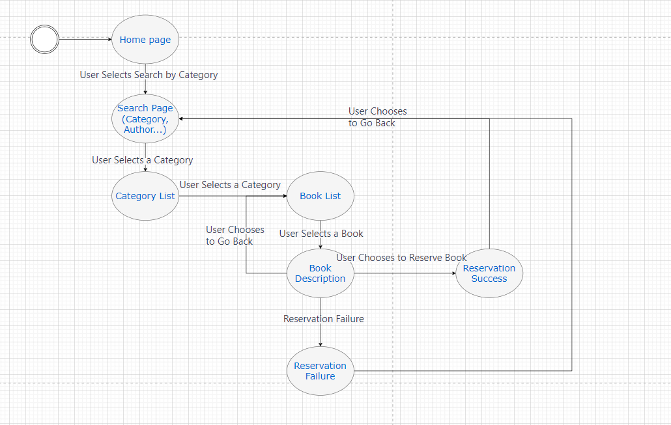

Test Scenarios:

**Scenario 1**: Searching for a Book by Category

User: Selects Search by Category

User: Chooses a Category

User: Selects a Book

**Scenario 2**: Searching for a Book by Author

User: Selects Search by Author

User: Enters Author's Name

User: Selects a Book

**Scenario 3**: Searching for a Book by Name

User: Selects Search by Name

User: Enters Book Name

User: Selects a Book

**Scenario 4**: Searching for a Book by ISBN

User: Selects Search by ISBN

User: Enters ISBN Number

User: Selects a Book

**Scenario 5**: Reserving a Book (Success)

User: Selects Search by Category

User: Chooses a Category

User: Selects a Book

User: Chooses to Reserve Book (Reservation Successful)

**Scenario 6**: Reserving a Book (Failure)

User: Selects Search by Category

User: Chooses a Category

User: Selects a Book

User: Chooses to Reserve Book (Reservation Failed)

**Scenario 7**: Navigating Back

User: Navigates Back at various points in the process.

Ці тестові сценарії охоплюють різні взаємодії користувача з програмою, зокрема пошук книг і резервування. Вони також враховують як успішні, так і невдалі спроби бронювання.